Solaris
Notebook

Written By: Shavit Ilan

Shell commands
Command | Explain
shutdown -y -i5 -g0 | Shutdown the machine
shutdown -y -i6 -g0 | Restart the machine
At Ok, prompt type:  at> boot –s | boot system to single user mode
cat /etc/release | Print Solaris version
prstat | Equivalent to top in linux
who -r | Show current run-level
prtdiag -v | To print hardware diag
useradd, userdel, groupadd | managing user@groups
snoop | Sniffer
prtconf -v  uname -i, arch -k | hardware config
format | Display all hard disks in the system
metastat | Information about raid

Add Static Route to Solaris

To add a Static Route you can use the route command to dynamically update the Kernel IP Routing table. However, when a server is restarted, these routes will be lost. To prevent this from happening, add a startup script S76static-routes with all the route commands that needs to persist.
Add a network:
# route add net 10.10.10.0 netmask 255.255.255.0 192.168.1.1 1
Add a host:
# route add host 1.1.1.1 netmask 255.255.255.0 192.168.1.1 1
To route traffic through an interface instead of Gateway
# route add 1.1.1.1/24 -interface hme0
To check that the routing table:
# netstat -rn

Static Routes at boot time
To make the routes available at boot time add all route commands to:
/etc/rc2.d/S76static-routes
and change the permissions to 744 (executable by root)

Solaris Timezone

Timezone defined in /etc/default/init

Add the lines to the file:

TZ=Israel

CMASK=022

to check when the system is going to change:
zdump -v Israel | grep 2009

Check the current time with the command:

date
(and see that you get the right time: IST)

Network card on Solaris
Command | Explain
netstat -rn | Print routing table
ifconfig -a | grep index | awk -F: '!/^lo0/ {print $1}' | Check which device(s) we have: ce0, ce1...
cat /etc/nodename | Check the hostname
cat /etc/netmasks | Check netmasks
/etc/resolv.conf | Configure DNS
/etc/hosts | Configure hosts
/etc/defaultrouter | Configure default gateway
ifconfig ce0 up | Start network card
ifconfig ce0 down | Stop network card
dladm show-dev | show network card devices
dladm show-link | show network card links

Sun Fire v240 – Hard Disk replacement
Remove HD With Solaris Running:
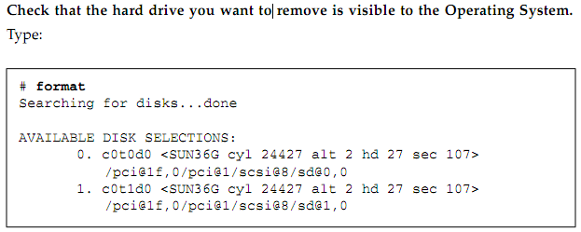
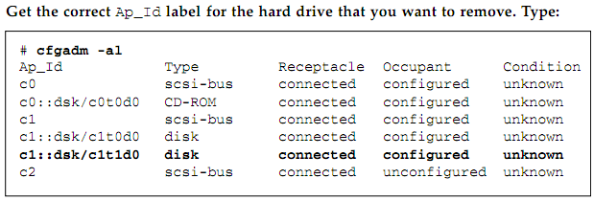

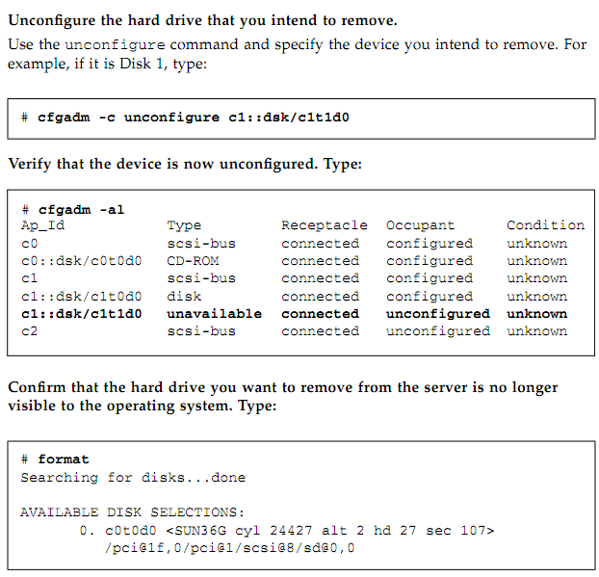
It is now safe to remove the HD

Install HD With Solaris Running:
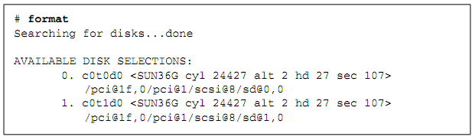

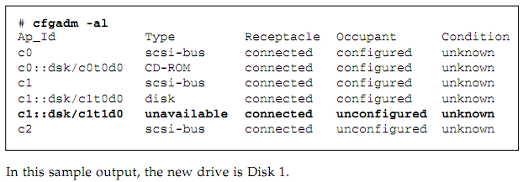

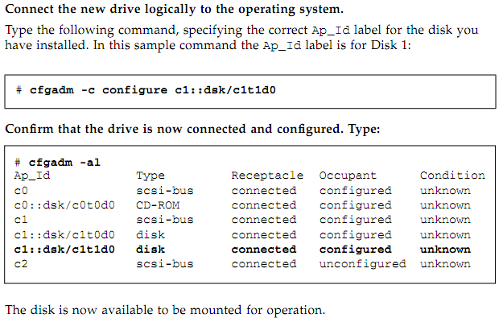

Solaris duplicate disk (dd) – Method A
Use HD with the same geometry (cylinders, heads, sectors) with the dd. In this example I will duplicate boot disk c0t0d0 with c0t1d0 on a Solaris system
# format
Searching for disks...done
AVAILABLE DISK SELECTIONS:
0. c0t0d0 <SUN9.0G cyl 4924 alt 2 hd 27 sec 133>
/sbus@1f,0/SUNW,fas@e,8800000/sd@0,0
1. c0t1d0 <SUN9.0G cyl 4924 alt 2 hd 27 sec 133>
/sbus@1f,0/SUNW,fas@e,8800000/sd@1,0
dd if=/dev/rdsk/c0t0d0s2 of=/dev/rdsk/c0t1d0s2 bs=1024k
mkdir /tmp/mnt
mount /dev/dsk/c0t1d0s0 /tmp/mnt
vi /tmp/mnt/etc/vfstab
:%s/c0t0d0/c0t1d0/g
:wq!
umount /tmp/mnt
Test booting from duplicate boot disk:
reboot -- disk1

Solaris duplicate Disk (dd) – Method B
For the purposes of this document:
disk0 is the source (c1t1d0), Disk1 is the clone (c1t2d0)
- Install both disks in system
- Start the machine and in the prompt 'ok' boot the original disk in reconfigure mode (to configure the clone disk). This step can be skipped if you do a ‘touch /reconfigure’ before you bring the system down to install the second disk
ok boot disk0 -r
- Reboot into single user on the source disk.
ok boot disk0 -s
- dd the source to the clone
dd if=/dev/dsk/c1t1d0s2 of=/dev/dsk/c1t2d0s2 bs=256k
- Verify the clone disk has a clean filesystem
fsck /dev/rdsk/c1t2d0s0
- mount the clone disk
mount /dev/dsk/c1t2d0s0 /mnt
- Change /etc/vfstab to point to the clone device typically this means changing the c1t1nnnn to c1t2nnnn
- touch /reconfigure on the clone to make sure it reconfigs it’s devices on next boot
touch /mnt/reconfigure
- Boot clone disk and Verify it works
ok boot disk1 -s

Solaris: Verifing RAID Configuration
metastat - give the information about raid configuration
